Parallel Sides
# Source: AI Source: Provided by: [Data Path: Persons Table -> ID Column: 1, Name_En Column: Motasem Essam] -> From: [ChatGPT] on [7/25/2026]
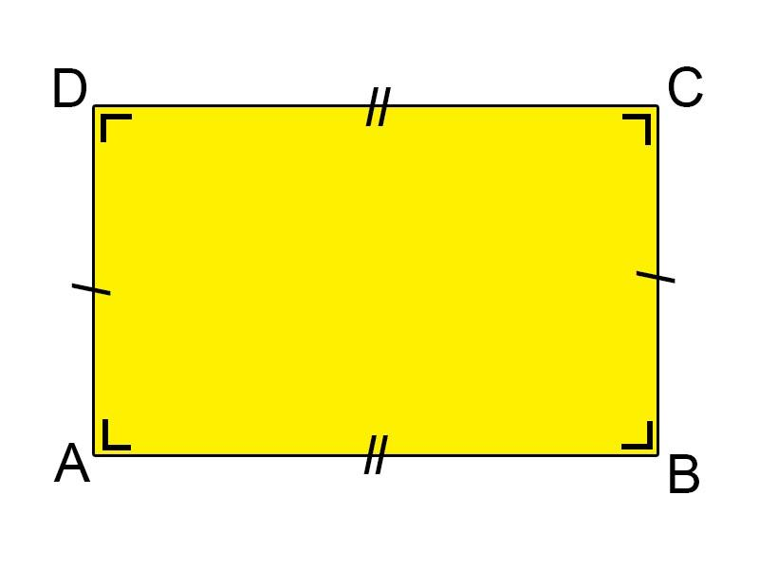
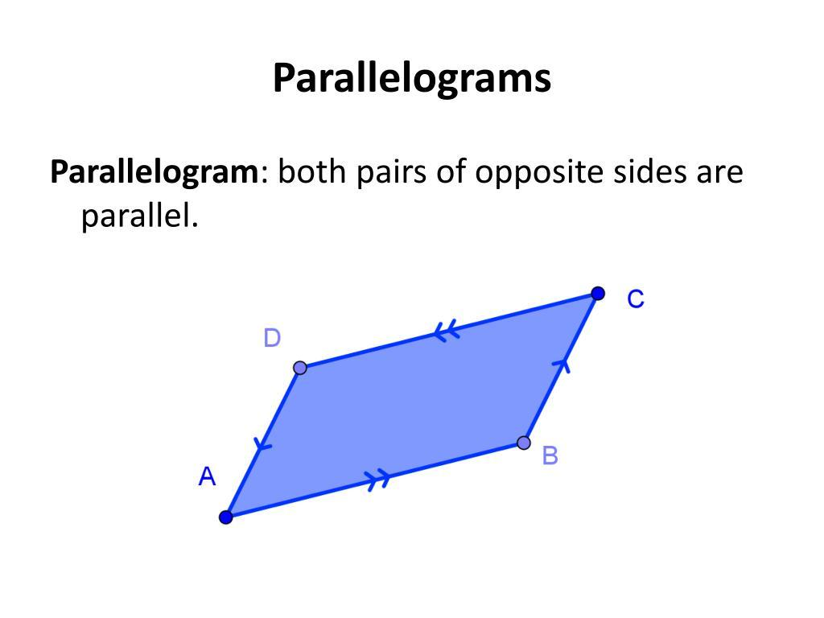
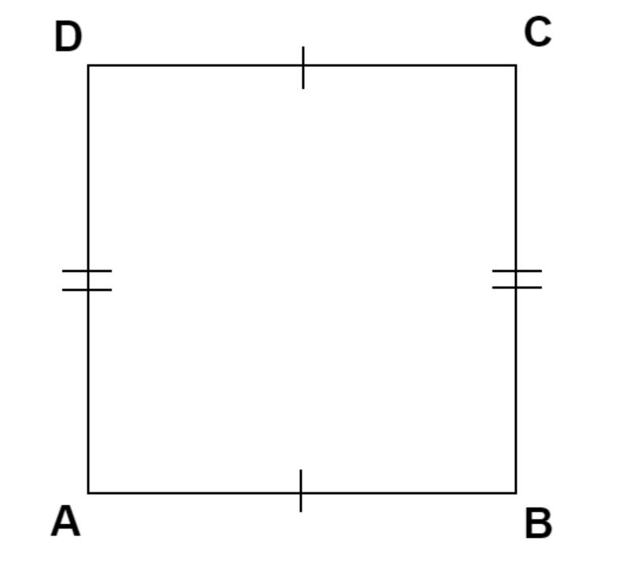
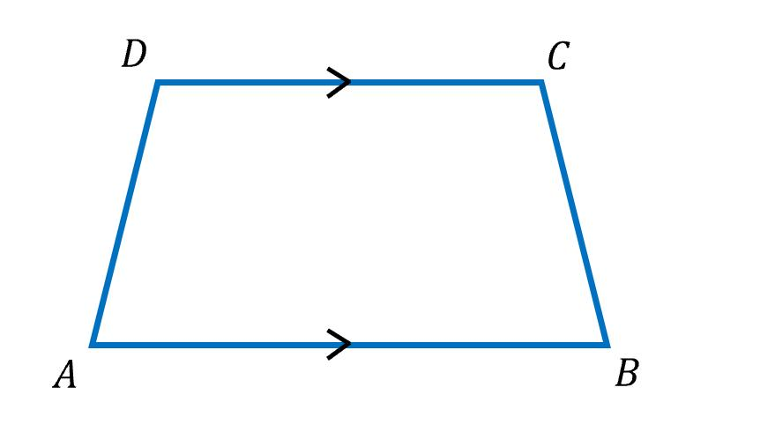
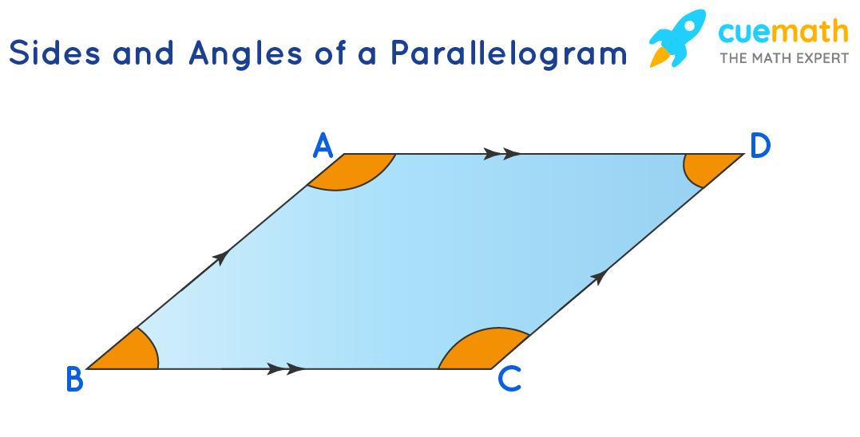
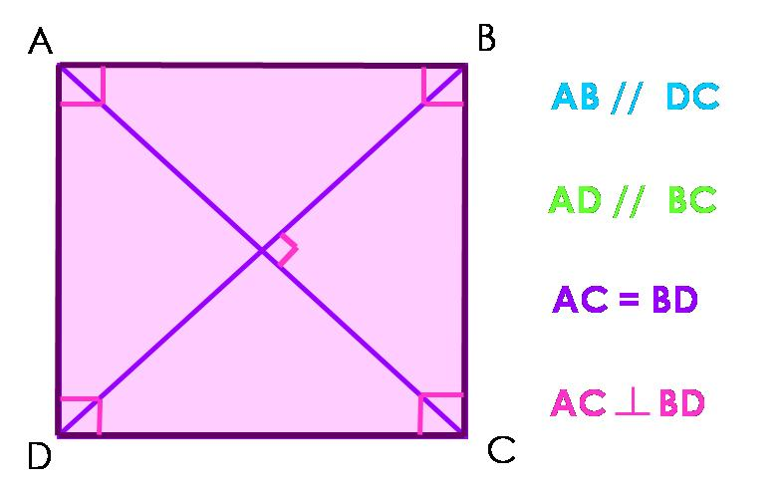

Definition
# Source: AI Source: Provided by: [Data Path: Persons Table -> ID Column: 1, Name_En Column: Motasem Essam] -> From: [ChatGPT] on [7/25/2026]
Parallel Sides are two sides of a geometric figure that lie in the same plane and never intersect, no matter how far they are extended. They always remain the same distance apart.
Parallel sides are commonly found in many polygons, especially rectangles, squares, parallelograms, rhombuses, and trapezoids.

Characteristics
# Source: AI Source: Provided by: [Data Path: Persons Table -> ID Column: 1, Name_En Column: Motasem Essam] -> From: [ChatGPT] on [7/25/2026]
Parallel sides:
- Lie in the same plane.
- Never intersect.
- Remain a constant distance apart.
- Extend infinitely without meeting.
- May be equal or unequal in length.
- Are represented mathematically by the symbol:
$$∥$$

Illustration

Rectangle
# Source: AI Source: Provided by: [Data Path: Persons Table -> ID Column: 1, Name_En Column: Motasem Essam] -> From: [ChatGPT] on [7/25/2026]

A────────B
│ │
│ │
D────────C
Parallel sides:
[
AB\parallel CD
]
[
BC\parallel AD
]

Parallelogram
# Source: AI Source: Provided by: [Data Path: Persons Table -> ID Column: 1, Name_En Column: Motasem Essam] -> From: [ChatGPT] on [7/25/2026]
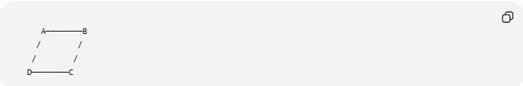
A────────B
/ /
/ /
D────────C
Parallel sides:
[
AB\parallel CD
]
[
BC\parallel AD
]

Mathematical Representation
# Source: AI Source: Provided by: [Data Path: Persons Table -> ID Column: 1, Name_En Column: Motasem Essam] -> From: [ChatGPT] on [7/25/2026]
If two sides are parallel:
$$\overline{AB}∥\overline{CD}$$
This means they never intersect.

Examples
# Source: AI Source: Provided by: [Data Path: Persons Table -> ID Column: 1, Name_En Column: Motasem Essam] -> From: [ChatGPT] on [7/25/2026]
Example 1 – Square
Parallel sides:
$$AB∥CD$$
$$BC∥AD$$

Example 2 – Rectangle
Opposite sides are parallel.

Example 3 – Trapezoid
Only one pair of opposite sides is parallel.
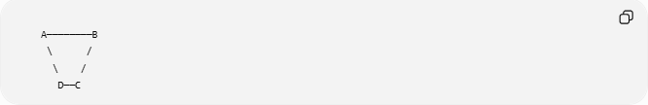
A────────B
\ /
\ /
D──C
Here:
$$AB∥DC$$

Properties
# Source: AI Source: Provided by: [Data Path: Persons Table -> ID Column: 1, Name_En Column: Motasem Essam] -> From: [ChatGPT] on [7/25/2026]
1. Constant Distance
Parallel sides always remain equally spaced.

2. Never Intersect
Even if extended indefinitely, they never meet.

3. Same Direction
Parallel sides have the same direction.

4. Common in Quadrilaterals
Shapes with parallel sides include:
- Rectangle
- Square
- Parallelogram
- Rhombus
- Trapezoid

Shapes Containing Parallel Sides
# Source: AI Source: Provided by: [Data Path: Persons Table -> ID Column: 1, Name_En Column: Motasem Essam] -> From: [ChatGPT] on [7/25/2026]

Shape | Parallel Sides
Rectangle | 2 pairs
Square | 2 pairs
Parallelogram | 2 pairs
Rhombus | 2 pairs
Trapezoid | 1 pair
Kite | Usually none

Real-World Examples
# Source: AI Source: Provided by: [Data Path: Persons Table -> ID Column: 1, Name_En Column: Motasem Essam] -> From: [ChatGPT] on [7/25/2026]
Parallel sides appear in:
- Roads.
- Railway tracks.
- Books.
- Doors.
- Windows.
- Tables.
- Bricks.
- Picture frames.
- Floor tiles.
- Computer monitors.

Applications
# Source: AI Source: Provided by: [Data Path: Persons Table -> ID Column: 1, Name_En Column: Motasem Essam] -> From: [ChatGPT] on [7/25/2026]
Parallel sides are used in:
- Plane Geometry
- Coordinate Geometry
- Engineering
- Architecture
- Surveying
- CAD (Computer-Aided Design)
- Computer Graphics
- Robotics
- Industrial Design
- Construction

Advantages
# Source: AI Source: Provided by: [Data Path: Persons Table -> ID Column: 1, Name_En Column: Motasem Essam] -> From: [ChatGPT] on [7/25/2026]
Studying parallel sides helps to:
- Classify polygons.
- Analyze geometric relationships.
- Solve angle problems.
- Understand symmetry.
- Design engineering structures.

Limitations
# Source: AI Source: Provided by: [Data Path: Persons Table -> ID Column: 1, Name_En Column: Motasem Essam] -> From: [ChatGPT] on [7/25/2026]
Parallel sides:
- Exist only within the same plane.
- Are not present in every polygon.
- May require additional information for complete figure classification.

Comparison with Related Concepts
# Source: AI Source: Provided by: [Data Path: Persons Table -> ID Column: 1, Name_En Column: Motasem Essam] -> From: [ChatGPT] on [7/25/2026]
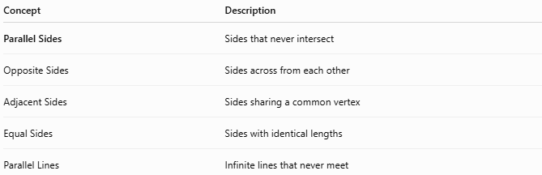
Concept | Description
Parallel Sides | Sides that never intersect
Opposite Sides | Sides across from each other
Adjacent Sides | Sides sharing a common vertex
Equal Sides | Sides with identical lengths
Parallel Lines | Infinite lines that never meet

Key Points
# Source: AI Source: Provided by: [Data Path: Persons Table -> ID Column: 1, Name_En Column: Motasem Essam] -> From: [ChatGPT] on [7/25/2026]
- Parallel Sides never intersect.
- They remain a constant distance apart.
- They are represented by:
$$∥$$
- Many quadrilaterals contain one or two pairs of parallel sides.
- Parallel sides are fundamental for studying polygons and angle relationships.

Conclusion
# Source: AI Source: Provided by: [Data Path: Persons Table -> ID Column: 1, Name_En Column: Motasem Essam] -> From: [ChatGPT] on [7/25/2026]
Parallel Sides are pairs of sides that lie in the same plane and remain equidistant without ever intersecting. They are a defining characteristic of many important polygons, including rectangles, squares, parallelograms, rhombuses, and trapezoids. The study of parallel sides is fundamental in plane geometry, coordinate geometry, engineering, architecture, surveying, CAD, computer graphics, robotics, industrial design, and construction, where they are essential for analyzing geometric relationships, classifying figures, and designing stable and accurate structures.

